joey blue

# Group by

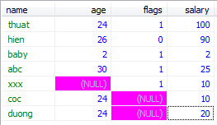

**SELECT** age,**sum**(salary),**min**(salary),**max**(salary),**count**(salary) **from** ntthuat_test **group** **by** age

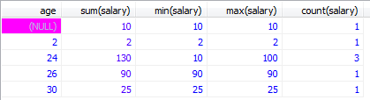

Nghia la nhung nguoi cung age se duoc cong vao 1 row

Muon biet co bao nhieu nguoi cung 1 muc luong t lam nhu sau:

**select** salary,**count**(name) **from** ntthuat_test **group** **by** salary

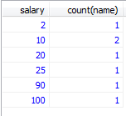

Nghia la co 2 nguoi cung muc luong 10 chai.

# Having



**SELECT** age,**sum**(salary),**min**(salary),**max**(salary),**count**(salary) **from** ntthuat_test **group** **by** age

**having** **min**(salary) >= 10

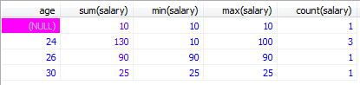

Group by ket hop having that la tuyet voi

# Upper – lower

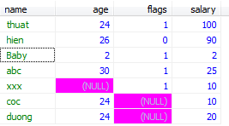

**select** **upper**(name) **from** ntthuat_test

hoac la:

**select** **ucase**(name) **from** ntthuat_test

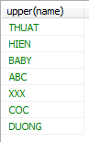

**select** **lower**(name) **from** ntthuat_test

hoac la:

**select** **lcase**(name) **from** ntthuat_test

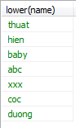

# Mid



**select** **mid**(name,1,3) **as** short_name **from** ntthuat_test

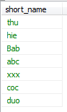

# length



**select** name,**length**(name) **as** length_name **from** ntthuat_test

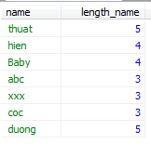

# Round

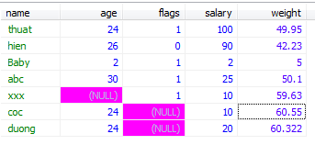

**select** name,weight,**round**(weight,1) **as** short_weight **from** ntthuat_test

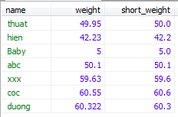

# Now()



**select** *,**now**() **from** ntthuat_test

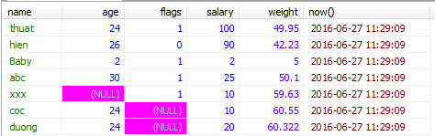

Now() return ve thoi gian luc query